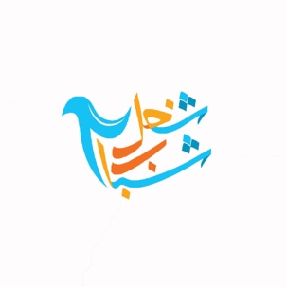
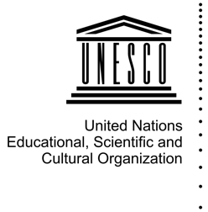
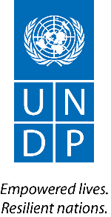

WAIVER FORM FOR SHUGHEL SHABAB

ADVOCACY CAMPAIGN 2017

IMAGE AND/OR VIDEO USAGE RELEASE FORM
(This is not a release for commercial use. This is for editorial use only.)

By signing this release form, I acknowledge that the submissions will be used for public use, be posted online platforms and potentially selected for publication in a UN document. My signature certifies that I have considered the safety risks associated with publication and have not submitted any image, video, or document that would put myself or anyone associated with the submission in harm.

By signing this release form, I hereby grant to the United Nations Development Programme (UNDP), United Nations Educational, Scientific and Cultural Organization (UNESCO), other UN agencies and Shughel Shabab the right to reproduce, display and disseminate worldwide and in perpetuity, in any traditional or electronic media format, my likeness as shown in the images or videos described below, which images are owned by UNDP, UNESCO, other UN agencies and Shughel Shabab, for the purposes of promoting youth peacebuilding efforts. Further, any text submitted to accompany the image or video also is owned by UNDP, UNESCO, other UN agencies and Shughel Shabab, which have the right to similarly reproduce, display and disseminate the text worldwide and in perpetuity in any traditional or electronic media format. UNDP, UNESCO, other UN agencies and Shughel Shabab reserve the right to edit the submissions for reproduction and dissemination. I certify that I hold the copyright of the footage, photograph, and/or infographic submitted or that I have the permission of its creator to submit. I also certify that I have the consent of the subject(s) of the footage, photograph and/or infographic.

____________________________ ____________________________
Name of Subject Birth Date

____________________________ ____________________________
Date Signature of Applicant

_____________________________________________________________________
Contact information

IF APPLICANT IS UNDER 18 YEARS OF AGE:

I confirm that I am the legal guardian of the child named above and therefore may grant permission for this applicant release on behalf of the child:

____________________ __________________ _____________ __________________
Name of Legal Guardian Relationship to Child Date Signature of Guardian

____________________ __________________ ___________ ____________________
Name of Witness Organization Affiliation Date Signature of Witness

SUBJECT CONSENT FORM

For group photos with no subjects under the age of 18:

The images and/or videos submitted as part of the 2017 Shughel Shabab media campaign were taken on (date) ___________________________________________ in the (location including town/country) _________________________________________________________________________ by (photographer’s name) _________________________________________________________________________. I further confirm that these images are a true likeness and the images were taken with each subject’s knowledge and consent.

____________________________ ____________________________
Date Signature of Applicant

_____________________________________________________________________
Contact information

IF SUBJECT OF PHOTO, INFOGRAPHIC AND/OR VIDEO IS UNDER 18 YEARS OF AGE:

I confirm that I am the legal guardian of the child named above and therefore may grant permission for this subject release on behalf of the child:

____________________ __________________ ___________ ____________________
Name of Legal Guardian Relationship to Child Date Signature of Guardian

____________________ __________________ ___________ ____________________
Name of Witness Organization Affiliation Date Signature of Witness

