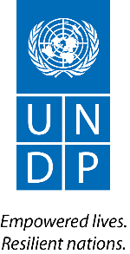
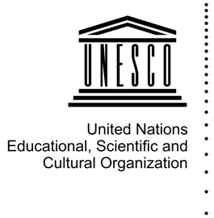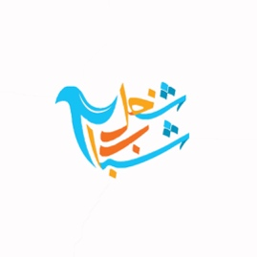
SUBMISSION GUIDANCE
Shughel Shabab – شغل شباب
Advocacy Campaign
2017

Have you worked to build peace in your community?
Would you like to share your story with peers to show the positive role young peacebuilders are playing across the Middle East and North Africa?
We invite you to become a part of Shughel Shabab! Submit your story! Have your voice heard!

Shughel Shabab is an advocacy campaign working to build space for young peacebuilders in the Middle East and North Africa. It will provide a platform to give young peacebuilders a voice, and to promote more inclusive policies and peace processes that make room for young peacebuilders in the region.

Shughel Shabab is led by a group of young peacebuilders from the region. We aim to change how youth from the Middle East and North Africa are perceived in the media, and consequently by governments and society, and help show how youth build peace. We want you to share your story to show the positive role youth play in their communities. In addition to a short narrative, we encourage you to include photos, videos and infographics that may best illustrate your story.

Shughel Shabab asks you to tell us your story! Share the peacebuilding problem facing your community, and what you have done to overcome it. Tell us the impact of your work on peacebuilding. Tell us how many people you reached, and how many people you inspired to join your cause. You can submit your story in one of three formats, and there are additional tips and guidance to make your submission as good as possible. The formats are as follows:

- Video: Videos must last between 2.5 and 5 minutes. In the video, you must explain your peacebuilding story. The file format must be saved as .mp4, .mov or .avi. Higher quality submissions are preferred. If filming on a phone, please make sure it is horizontally oriented and that the sound quality is good (tip: your headphones often have built-in microphones).

- Infographic: Infographics must align with the standard guidance available on Youth4Peace, and highlight your story of your work on peacebuilding. Infographics should be high quality and feature either the scope of the peacebuilding challenges the youth peacebuilder faces or the impacts of his or her work on peacebuilding in his or her community. The file format must be saved in .jpeg and be at least 1.5 MB. Higher quality submissions are preferred.

- Photographic Essay: Photographic essays must include at least 3 images and no more than 7. Photographs must be high quality, and highlight your story of your work on peacebuilding. The file format must be saved in .jpeg and be at least 1.5 MB (4000 pixels, long edge and at 300 dpi). When you upload your submission to DropBox, please submit the photos as individual files and also upload a Word document containing the 100-word caption for each image. The captions for the photo essay should capture your peacebuilding story.

Your video, photographic essay or infographic must be uploaded to Dropbox (more information under “How to Enter”).
Shughel Shabab is looking for inspiring stories of peacebuilding. Consider sharing the challenges you have overcome in your work, and highlighting the impact you have had on peace in your community. The campaign is supported by UNDP and UNESCO on behalf of the Regional UN Interagency Effort.
CAMPAIGN PERIOD: The period for submission is open from 31 July 2017 to 1 December 2017. Any submissions received before or after this period will not be considered as submissions for the contest.

RECOGNITION: Out of the entries, 100 stories will be selected for a joint publication – “100 Most Inspiring Stories of Youth Building Peace in the Arab Region” – by UNDP and UNESCO. This publication will be distributed in a limited print and available online. In addition, certificates of recognition will be prepared for the top ten peacebuilding stories.

HOW TO ENTER: Your video, photographic essay or infographic must be uploaded to Dropbox following this link: https://www.dropbox.com/request/MiAkJPaCk0p5TbHi2cx2. To be considered for the recognition, please fill in and upload the application form along with your video, infographic or photographic essay to the Dropbox folder in a zip folder. A waiver form must also be submitted if your video, infographic, or photo essay includes an image of a person, including yourself.

Please upload the actual files of your video, photographs or infographic. Do not send links to YouTube videos, but upload the actual video file. Do not put photos into a poster or Word document, but instead upload each photo as a file.

We also encourage you to upload your video, photographic essay or infographic to your social media platforms and use the hashtag #youth4peace.

For additional information, please contact the youth group at ypsarab@gmail.com.

All forms can be found of the Youth4Peace website.

SUBMISSION CRITERIA: Entries that are incomplete or do not adhere to the guidelines and rules may be disqualified. Multiple entries by the same person will also be disqualified.

On all submissions, there can be no watermarks. The file names should be saved with Shughel Shabab, your first and last name, and the country in which you are working for peacebuilding (for example, ShughelShabab_AhmedAhmed_Algeria).

Each submission must highlight your story, and show how you are working to promote peace in your community. Each submission must also show the impact of your work on peacebuilding.

APPLICANT CRITERIA: Applicants must be between the ages of 15-35 for the duration of 2017. Applicants must be natives of one of the following countries, and engage in peacebuilding work that has direct impacts on people from or residing in one of the following countries:

- Algeria
- Bahrain
- Djibouti
- Egypt
- Iraq
- Jordan
- Kuwait
- Lebanon
- Libya
- Morocco
- Oman
- Qatar
- Saudi Arabia
- Somalia
- State of Palestine
- Sudan
- Syria
- Tunisia
- UAE
- Yemen

